Project Plan

For an Intrusion Detection System using a Neural Network

Version 2.0

Submitted in partial fulfillment of the requirements of the degree of MSE

Blake Knedler

CIS 895 – MSE Project

Kansas State University

Table of Contents

1 Introduction 3

2 Work Breakdown Structure 3

2.1 Objective Phase 3

2.2 Architecture Phase 4

2.3 Implementation Phase 4

3 Cost Estimate 5

3.1 COCOMO 5

4 Architecture Elaboration Plan 7

4.1 Revise Vision Document 7

4.2 Revise Project Plan 7

4.3 Create Formal Specification 7

4.4 Create Architectural Design 7

4.5 Create Test Plan 7

4.6 Conduct Technical Inspection 7

4.7 Create Executable Architecture Prototype 7

# Introduction

This project plan document is an outline that shows the work breakdown structure, provides a cost estimate analysis, and describes the activities that will be performed during the architecture elaboration phase of the project.

# Work Breakdown Structure

The IDS project will follow a waterfall process which will consist of three phases. Phase 1 is the objectives phase, Phase 2 the architecture phase and Phase 3 which is the implementation phase. Figure 1 below shows the Gantt Chart for the project. The first phase of the project will be completed in the Summer of 2016 with Phases 2 and 3 being completed in the Fall of 2016.

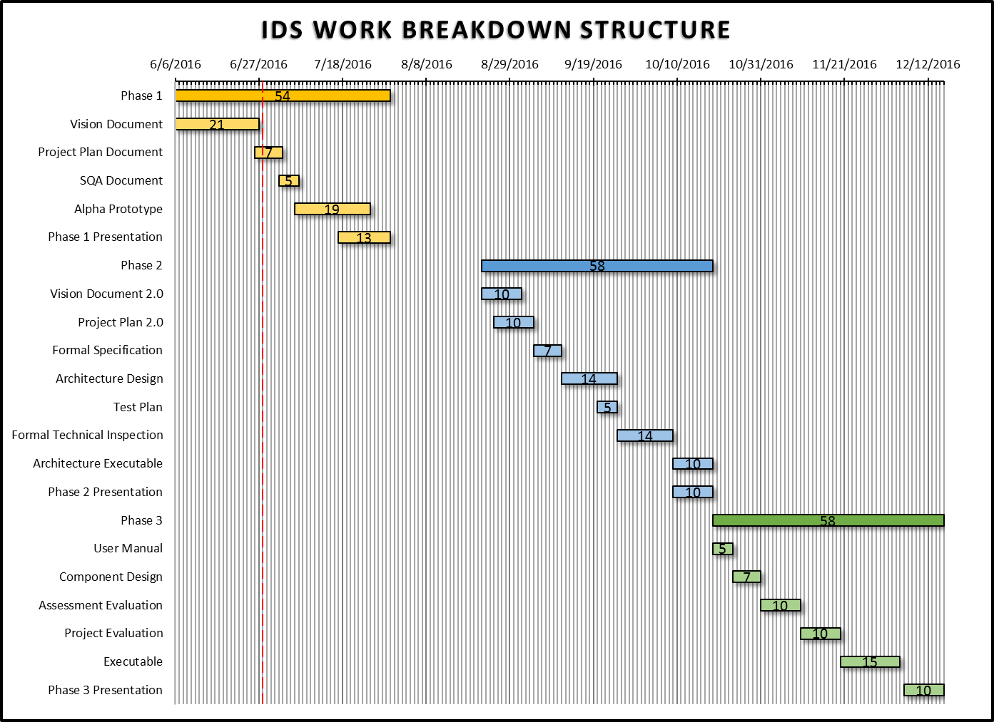

Figure 1. IDS Project Gantt Chart

## Objective Phase

During the Objective Phase (Phase 1) the objectives will be set for the project. This phase includes the creation of a vision document, a project plan, a Software Quality Assurance (SQA) plan, and an Alpha prototype of the project. During this phase the initial critical requirements and design will be determined for the project. The vision document will aim to portray the main vision for the project which includes the motivation for the project, the project overview and goal, and the main requirements specification. The project plan will lay out what work will be accomplished and the timeline of this progress. Additionally, the project plan will estimate the cost of the project. The SQA plan will outline the required documentation, standards and conventions, error tracking, and tools that will be used during the project. The plan will identify the quality metrics that will be used to assess the systems quality attributes.

## Architecture Phase

During Architecture Phase of the project, the vision document and project plan will be reworked and adjusted according to feedback given after the Objective Phase. Also during this phase, the complete architecture and design of the project will be determined and shown in UML diagrams. This will be done in the Architecture Design document. Also, a formal specification of one part of the project will be published using a formal methodology. A Test Plan will also be created which will address the required tests that will confirm the project meets its expected requirements. Along with these documents, a formal inspection will be done on the project which will come from two technical inspectors who will provide feedback to the architecture of the project. Lastly, an executable Architecture Prototype will be created which will address al critical requirements that were identified in the vision document.

## Implementation Phase

During the final phase of the project, the Implementation Phase, the in depth component design will be created. Along with the component design document a user manual will also be created which will demonstrate how to use the IDS system properly. The entire project shall be tested according to the test plan and unit testing will be done on the individual components. This phase will end with a completed system executable and multiple evaluations on the system.

# Cost Estimate

## COCOMO

For this project, the COCOMO, Constructive Cost Model, software cost estimation model will be used to estimate the cost of the project in both effort and time. The COCOMO model is an algorithm developed by Barry Boehm in 1981. Over time it has been adjusted some and therefore the Intermediate COCOMO formula will be used on this project. This project will consist of only one software developer on an organic software project. The two main algorithms that will be used for this cost estimation will measure the effort of the project in man-months and the time in months. These equations are as follows:

$$Effort \left(man-months\right)=3.2 ×{(KLOC)}^{1.05}×EAF$$

$$Development Time \left(months\right)=2.5 ×{(Effort)}^{0.38}$$

In the first equation, there are two unknowns. These unknowns are KLOC, which is the estimated source lines of code size in thousands, the other unknown is EAF which stands for Effort Adjustment Factor. The estimated KLOC for the project is 4 due to a best guess and from research gathered. The EAF was determined as shown in Figure 2 below.



Figure 2. Effort Adjustment Factor Table

Overall, this project has a higher complexity due to the nature of neural networks and the requirement for speed due to the fact that the system will need to read network traffic in an efficient manner to warn the user in an appropriate amount of time.

Based on these estimates, the total EAF value is 0.9342. This means that the following equations will be as follows:

$$Effort \left(staff-months\right)=3.2 ×{(4)}^{1.05}×0.9342=12.82 man-months$$

$$Development Time \left(months\right)=2.5 ×{(12.82)}^{0.38}=6.59 months$$

The timeline for this project should around 6.59 months. This seems to be a reasonable estimate considering this project is being spread across two semesters which will equate to 6 months in total. However, since this is a school project the constraints of working nights and weekends can be ignored and therefore is a reasonable estimate for the project.

# Architecture Elaboration Plan

The following tasks outline the main artifacts that will be completed during the Architecture Elaboration Phase of the project.

## Revise Vision Document

The original vision document will be reworked based on feedback given from the first phase of the project. The changes will come from the knowledge gained during the development of the Alpha prototype and committee feedback. This will mainly be any modified, added, or removed critical requirements and use cases of the system.

## Revise Project Plan

The original project plan will be revised based on the feedback given from the initial phase of this project. These modifications will mainly affect the schedule and effort factors after gaining knowledge from the Alpha prototype.

## Create Formal Specification

A part of the system will be formally specified. This will be the neural network part of the system since it is the most complex and largest piece of the system. It is essentially the brains of the system and will therefore the most formal specification will be done on it.

## Create Architectural Design

The complete architectural design of the system will be created. This design will use UML diagrams to portray the architectural design of the system. These diagrams will include sequence diagrams, class diagrams, activity diagrams, etc.

## Create Test Plan

A test plan for the project will be completed during the elaboration phase. This test plan will include a written plan for assessing the correctness of the critical requirements of the system. This plan will include both unit test and integration testing for all the requirements.

## Conduct Technical Inspection

The project will also undergo technical inspection by two fellow colleagues. These colleagues will be Tracy Marshall and Keith Moyer. These inspectors will look at the architectural design of the system and provide feedback. Any feedback will from these inspectors will propagate through the documents as modifications.

## Create Executable Architecture Prototype

An executable architecture prototype of the system will be created. This prototype will touch on all of the critical use cases that were outlined in the vision document.